IFB299 – Application Design and Development

**Personal Portfolio --- Zhentian liu, n9298754**

I am a member of team number 5, and this group including 6 people. There are 4 people are CS students，and 2 people are IS students. I am one of the developers of team number 1 and the client of team number 6. The following artefacts are my contribution to my team.

* Writing and developing two user stories.

User story 20



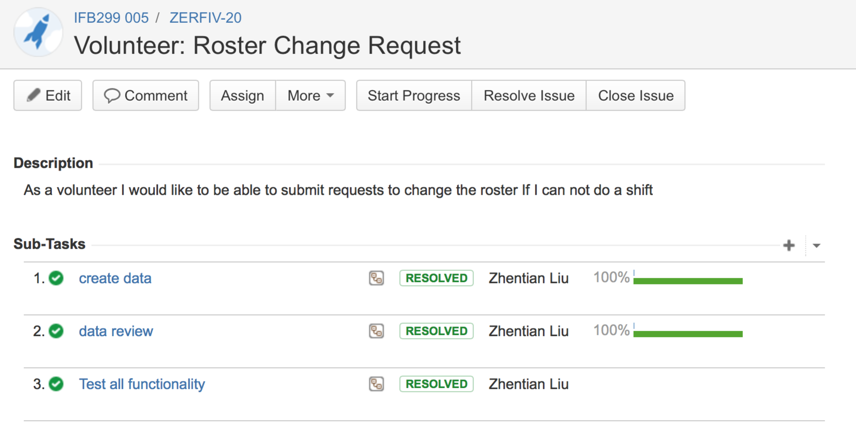

User story 7



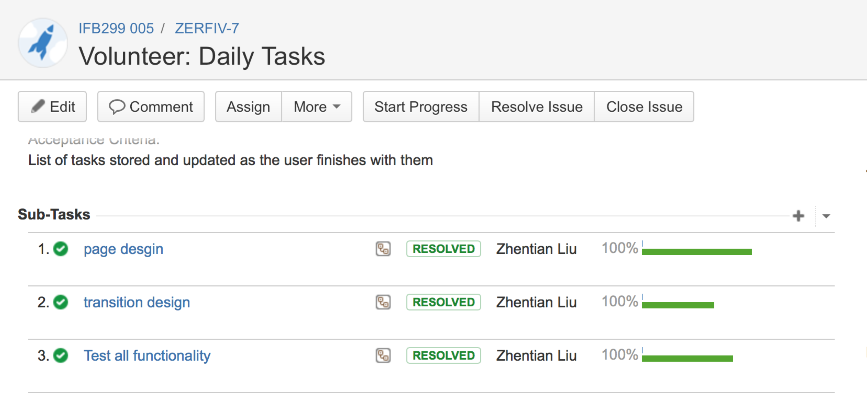

* Attending the group meeting about the classification of the user stories so that we can make decisions on which stories should be done first.

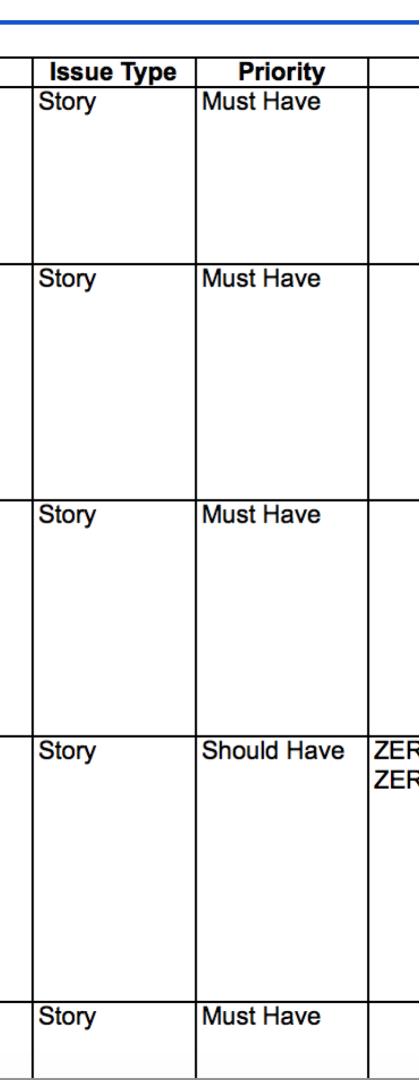

* My team and I have a meeting, and I also communicated with them on the Facebook about the peer review1 for the team number 6.

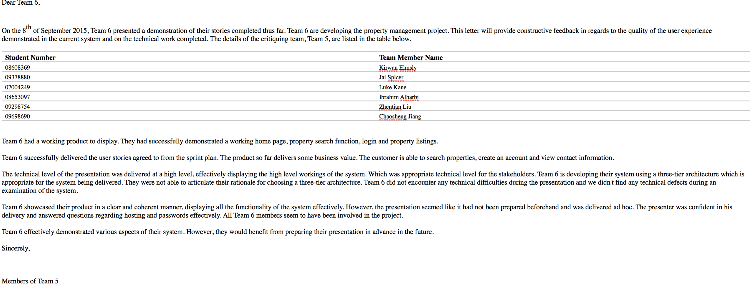

* do some tests about the login. Website and home. Page

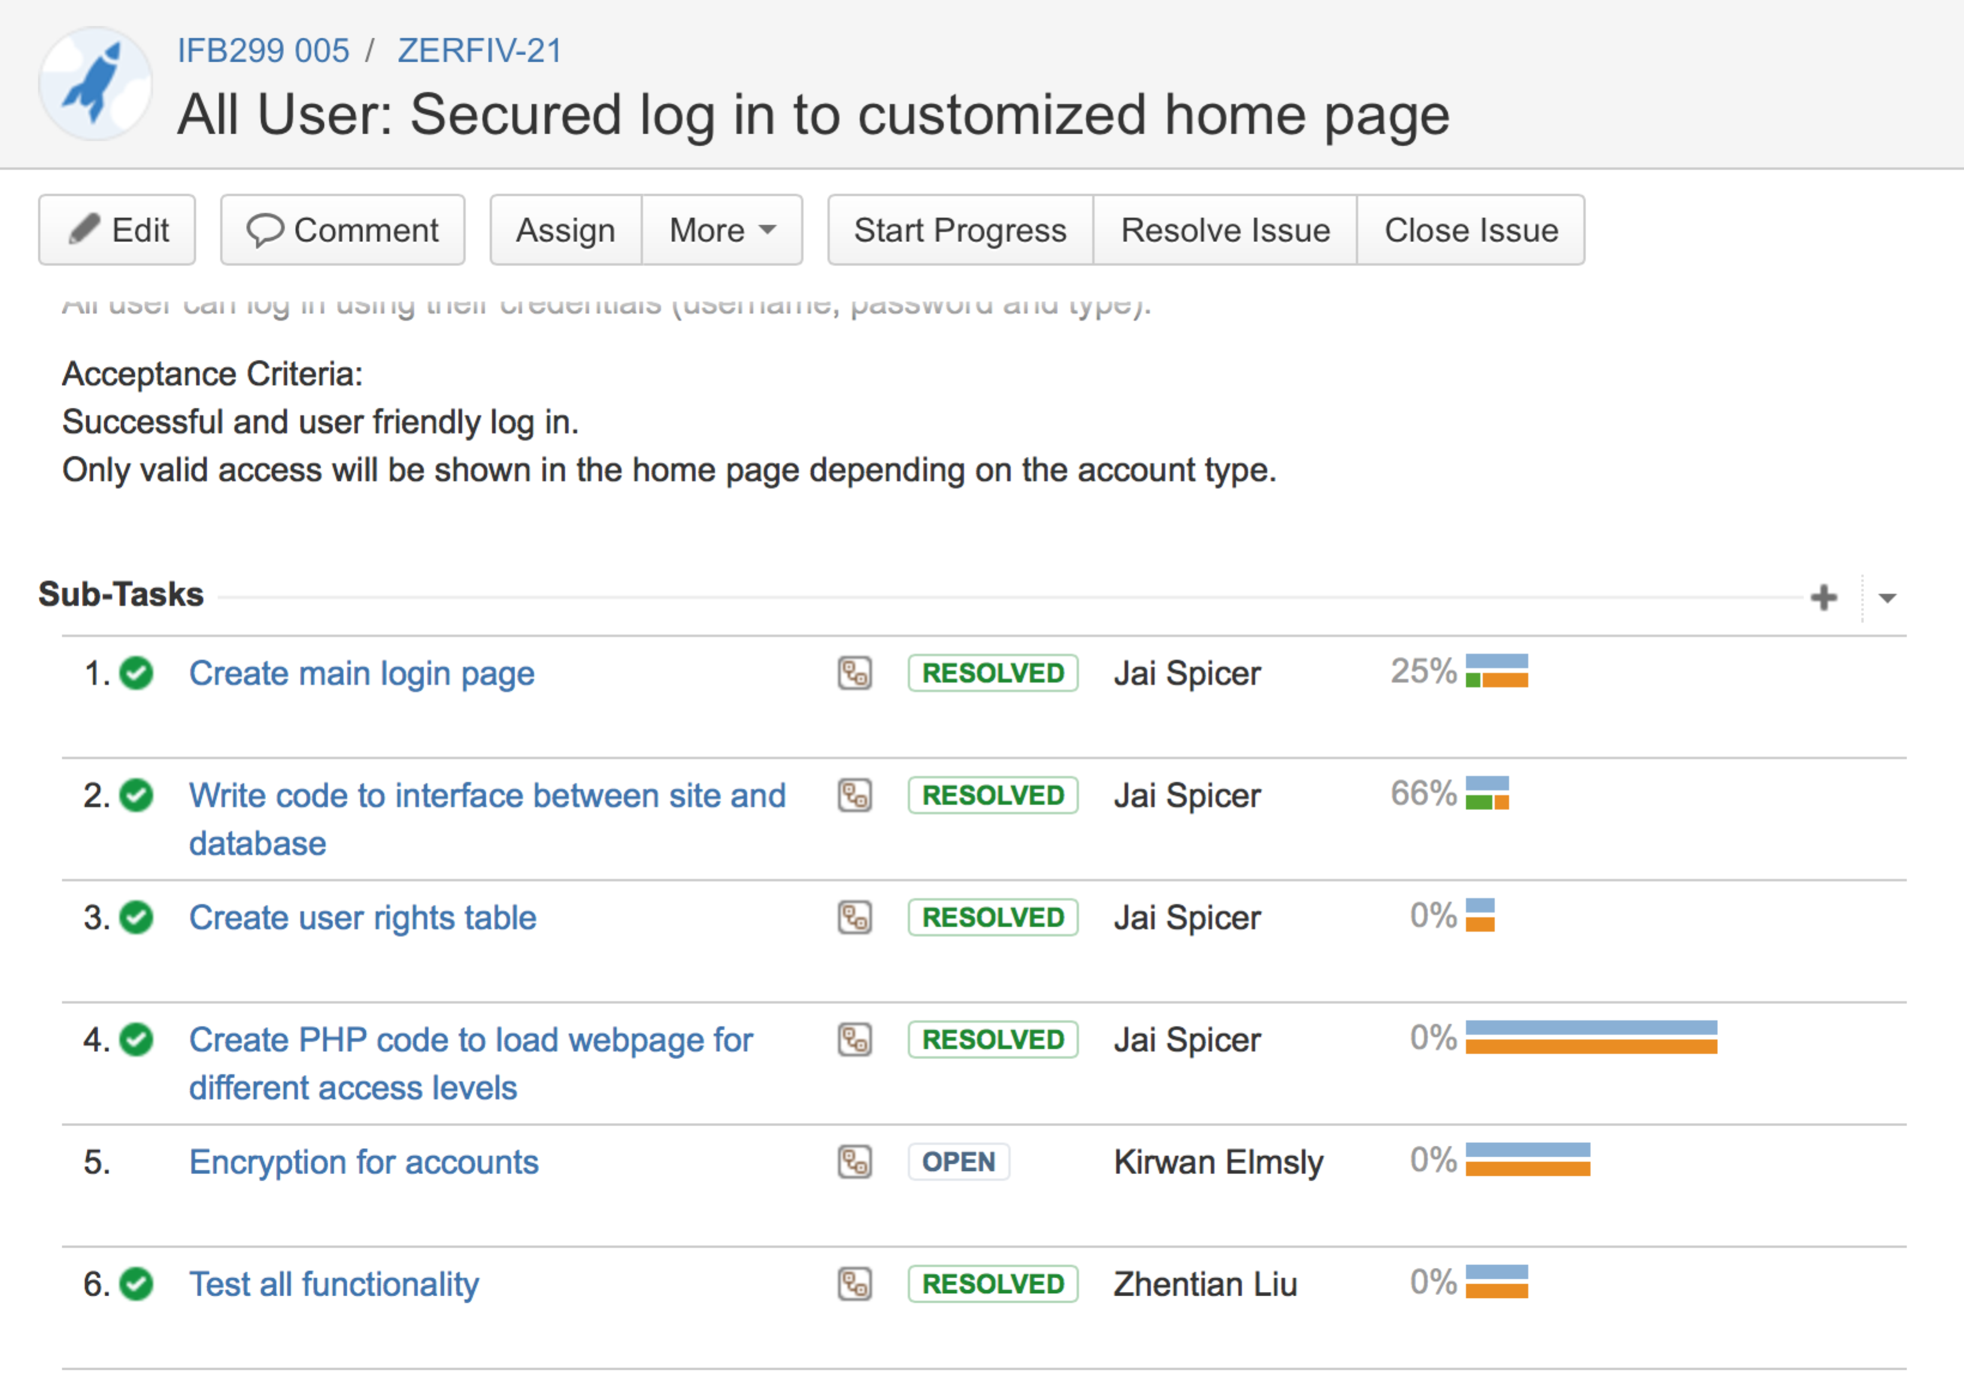

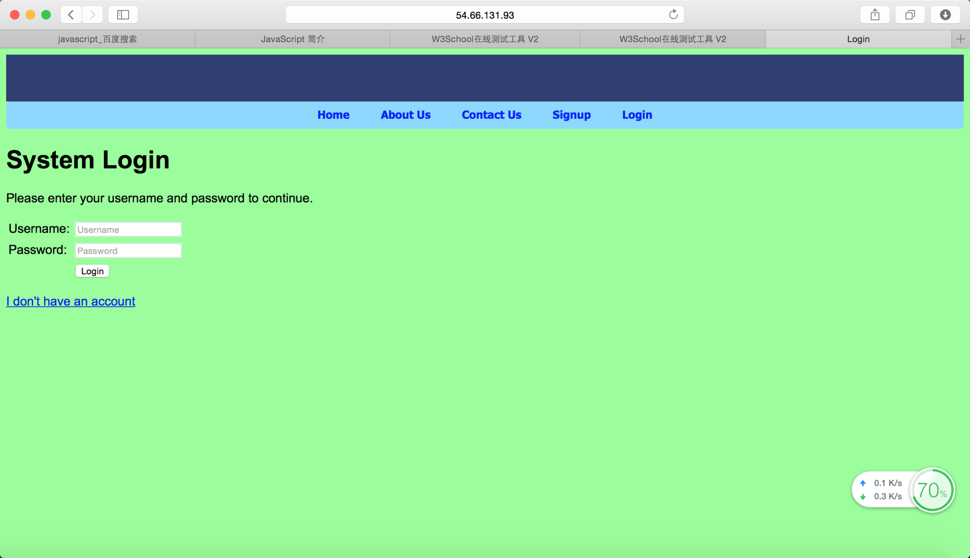

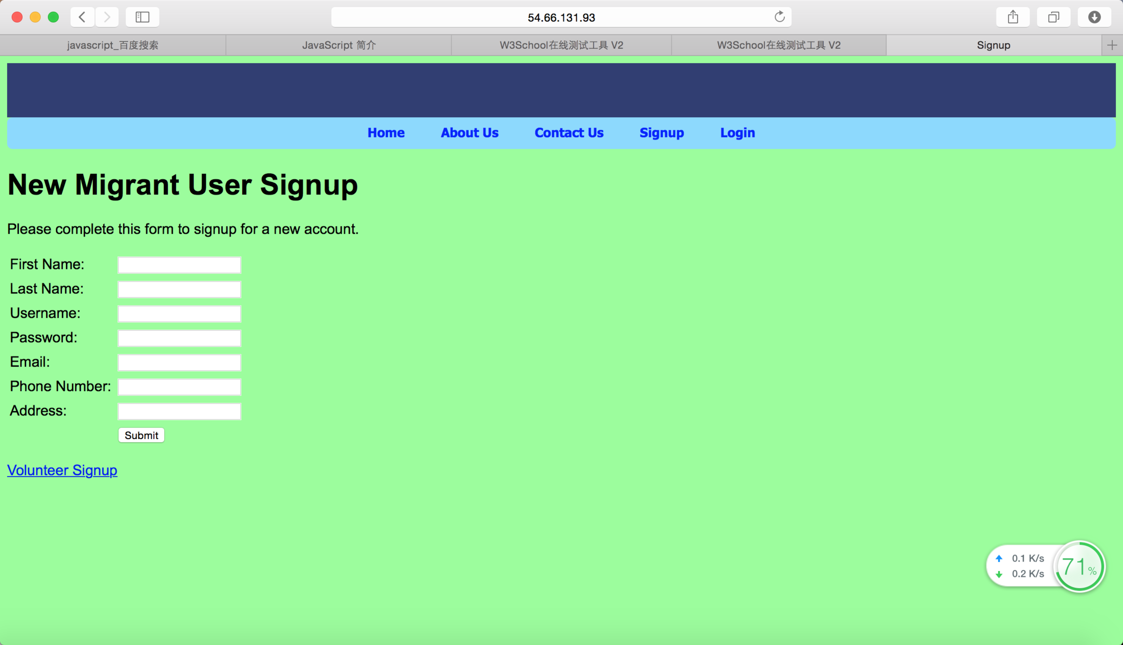

* I attend the group meeting with the client and summarized the feedbacks, and I sent it to the group presenter on the Facebook.